

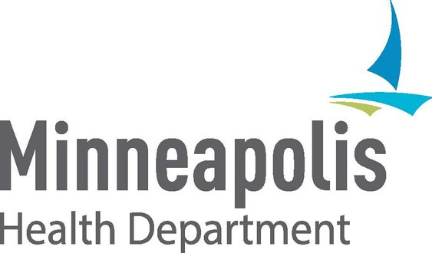Get vaccinated

and keep your workplace safe!

If you work in Minneapolis, you have the right to use your available sick time to go to a vaccination appointment and for recovering from vaccine side effects.



**Did you know?**

To learn more about sick leave, call 311 or 612-673-3000.

**USE YOUR SICK LEAVE TO GET VACCINATED**

Make your plan to get your vaccine. Register for a vaccine appointment or find a clinic that welcomes walk-ins.

**1**

**2**

Talk to your supervisor if you need time off. Tell them you plan to use your available sick time to get vaccinated.

**3**

If you get a vaccine with two shots, side effects after the second one may be stronger. If possible, plan to take the day off after your second shot.

You can also get vaccinated when you are not working.

Some vaccination clinics have morning, evening and weekend hours.

**Find clinics and hours at:** [**www.tinyurl.com/mplsvax**](http://www.tinyurl.com/mplsvax) **or** [**www.mn.gov/covid19/vaccine/find-vaccine**](http://www.mn.gov/covid19/vaccine/find-vaccine)